Homework 6 STAT:3210 Experimental Design and Analysis

Yubing Li 00808366

**1. Problem 5.4:**

(a) **Feed Rate: $H_{o}: τ_{1}=τ_{2}=τ_{3}=0 vs H_{a}: τ_{j}≠0$** for at least one j

**Depth: $H_{o}: β_{1}=β_{2}=β_{3}=β_{4}=0 vs H_{a}: β_{j}≠0$** for at least one j

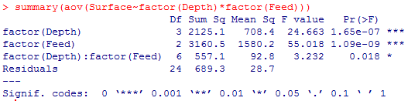**Interaction: $H_{o}: {τβ}_{11}=…={τβ}_{34}=0 vs H_{a}: {τβ}_{ij}≠0$** for at least one i, j

Since the p-values for depth, feed rate, and the interaction term are smaller than 0.05, we **reject the null hypothesis** and conclude that they are **significant difference** in depth, feed rate and their interaction.



(b)

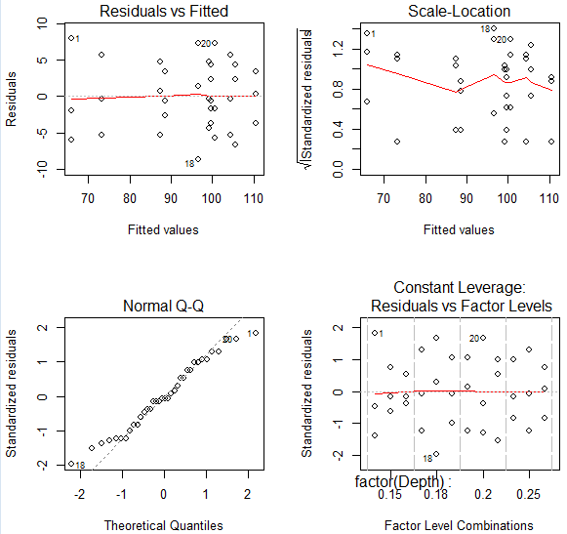**Independence**: the residuals are randomly distributed in the plot.

**Normality**: they are close to the diagonal reference line.

**Constant Variance**: the plot doesn’t show much pattern against the homogenous variance assumption.

In all, **the three model assumptions are not violated.**

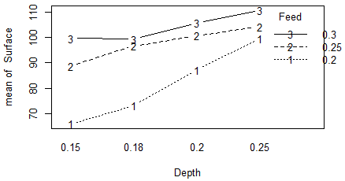(c) From the F test, we conclude that feed rate and depth have significant interaction.

In the interaction plot,

(e) HSD:

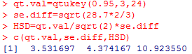 1) HSD = 10.9236

0.25 vs 0.2: **22.6667 > HSD**

0.3 vs 0.2: **33.6667 > HSD**

0.3 vs 0.25: **11.0000 > HSD**

Since the pairwise difference estimates are larger than HSD for **all three pairs**, the mean surface for all three comparisons are **simultaneously significantly different**.

With error rate of 0.05 experiment-wise for all three comparisons.





2) HSD = 10.9236

0.25 vs 0.2: **4.6667 < HSD**

0.3 vs 0.2: **11.0000 > HSD**

0.3 vs 0.25: **6.3333 < HSD**

Since the pairwise difference estimate is larger than HSD for **0.3 vs 0.2**, the mean surface is **simultaneously significantly different** for feed rate of 0.2 and 0.3.

For feed rate **0.25 vs 0.2**, and feed rate **0.3 vs 0.25**, the estimates are smaller than HSD, we conclude they are **not simultaneously significantly different** for each pair, with error rate of 0.05 experiment-wise for all three comparisons.





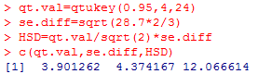3) HSD = 12.0666

0.15 vs 0.18: **33.333 > HSD**

0.15 vs 0.2: **6.000 < HSD**

0.15 vs 0.25: **11.000 < HSD**

0.18 vs 0.2: **6.333 < HSD**

0.18 vs 0.25: **11.333 < HSD**

0.2 vs 0.25: **5.000 < HSD**

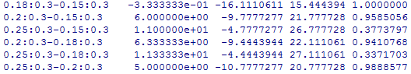

Since the pairwise difference estimate is larger than HSD for depths **0.15 vs 0.18**, the mean surface is **simultaneously significantly different** for depths 0.15 vs 0.18.

For depths **0.15 vs 0.2,** **0.15 vs 0.25, 0.18 vs 0.2, 0.18 vs 0.25,** and **0.2 vs 0.25**, the estimates are smaller than HSD, we conclude they are **not simultaneously significantly different** for each pair, with error rate of 0.05 experiment-wise for all three comparisons.

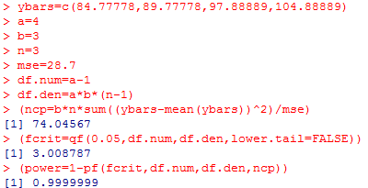

(f) The power for the depth effect is **0.9999999.**

|  |  |  |  |
| --- | --- | --- | --- |
| n = | 4 | 5 | 6 |
| Power = | 0.8401 | 0.9244 | 0.9663 |

(g) The necessary number of replicates is **n = 5**.

**2. Problem 5.16:**

(a) **No**. The df of error is ab(n-1). When n is 1, df becomes 0. Therefore we don’t have interaction term in the model.

(b) **Pressure: $H_{o}: τ_{1}=τ_{2}=τ_{3}{=τ}_{4}=0 vs H_{a}: τ_{j}≠0$** for at least one j

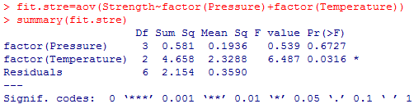**Temperature: $H_{o}: β_{1}=β_{2}=β_{3}=0 vs H_{a}: β_{j}≠0$** for at least one j

Since the p-value for pressure is larger than 0.05, and p-value for temperature is smaller than 0.05, we **can’t reject** the null hypothesis for **pressure** and conclude it’s **not significant** to the model. We **reject** the null hypothesis for **temperature** and conclude it’s **significant** to the model.

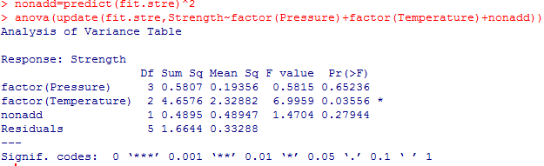(c) H0: the model is additive vs. Ha: the model is non-additive

Since the p-value for non-add term is larger than 0.05, we reject the null hypothesis and conclude that **the model is non-additive**.

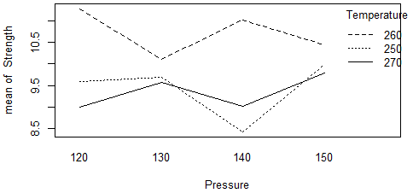(d)

The lines are not very parallel, indicating mild interaction between the two factors.

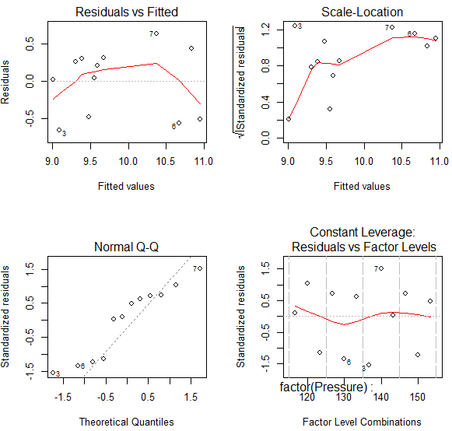(e) Normality:

Since the residuals are close to the diagonal reference line in the normal Q-Q plot, the **normal assumption is not violated**.

Constant Variance:

In the residual vs. fitted value plot, there’s no obvious violation against homogeneous variance. Therefore, the **constant variance assumption is not violated**.

(f) HSD:

1) Different Pressure:

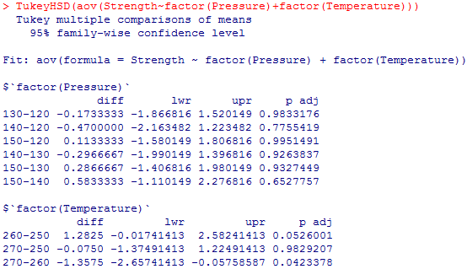After accounting for temperature, with error rate of 0.05 experiment-wise for all three comparisons.

**3. Problem 5.18:**

(a) H0: the main effects are not significant vs. Ha: not H0

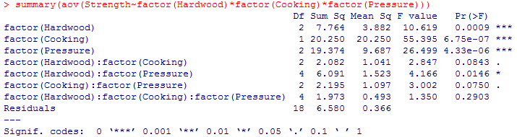H0: the interaction effects are not significant vs. Ha: not H0

Since the p-values for hardwood, cooking, and pressure are smaller than 0.05, we **reject** the null hypothesis and conclude the main effects are **significant** to the model.

For interaction terms, the p-value of **hardwood and pressure** is smaller than 0.05. Therefore we reject the null hypothesis and conclude the interaction between the concentration of wood and the pressure is **significant** to the model, while others’ are **not significant**.

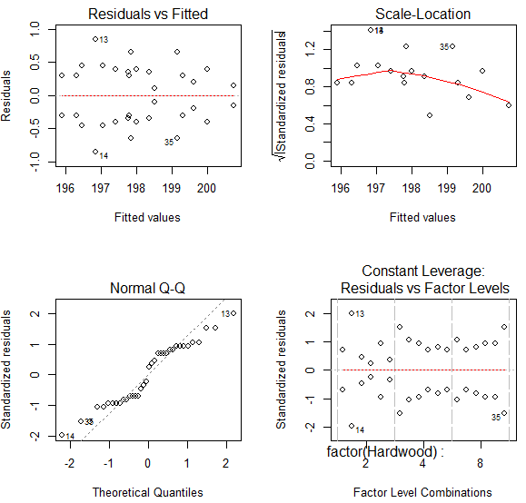(b)

(c) The experiment is **three-factor factorial** designed.

The response variable is strength of the paper (**Strength**).

The replicates n is **2**. The total sample size is **36**.

|  |  |  |
| --- | --- | --- |
| Treatment factors: | Levels: | |
| Concentration (**Hardwood**) | 3 | 2, 4, 8 |
| Cooking time (**Cooking**) | 2 | 3 hrs. 4 hrs. |
| Vat pressure (**Pressure**) | 3 | 400, 500, 650 |

(d) The **hardwood and pressure** have significant interaction.

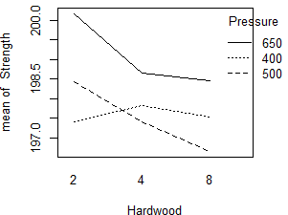

The lines interact, which indicates the hardwood and pressure interaction is significant. It’s consistent with the result in the F test.